School of Electrical Engineering, Belgrade

Coursework for Software Engineering Principles (SI3PSI)

**Project: CodeUp**

*Database specification*

Document version: 1.0

Table of Contents

1. Introduction 3

1.1. Goal of this database 3

1.2. The target group 3

1.3. Document organization 3

1.4. Concern 3

2. Database model 4

2.1. IE notation 4

2.2. Schema of relational database 4

3. Tables 5

3.1. User 5

3.2. Country 5

3.3. Bug 5

3.4. Request 6

3.5. Category 6

3.6. Subcategory 6

3.7. ProblemStatement 7

3.8. Solution 7

3.9. Test 7

3.10. ProblemStatements-Test 7

# 1. Introduction

## 1.1. Goal of the database

Goal of the database is to reliably store information about our users, as well as the problem statements that this platform will offer to our users. Also, for every problem statement in our database, the database will store corresponding test cases.

In this document, the database will be presented in IE notation. In addition to that, this document will present a description of the tables that this database contains.

## 1.2. The target group

The database model should enable easier communication between developers and management. The project leader will use this document to plan the development team’s activities, and the development team will use it as the basis for the implementation.

Also, new team members will be able to integrate into team more easily.

## 1.3. Document organization

The rest of the document contains two more chapters:

1) Data model – data model in our database,

2) Table – each table will be described individually.

## 1.4. Concerns

|  |  |  |
| --- | --- | --- |
| Number | Date | Problem/Solution |
|  |  |  |
|  |  |  |
|  |  |  |
|  |  |  |

# 2. Database model

## 2.1. IE notation

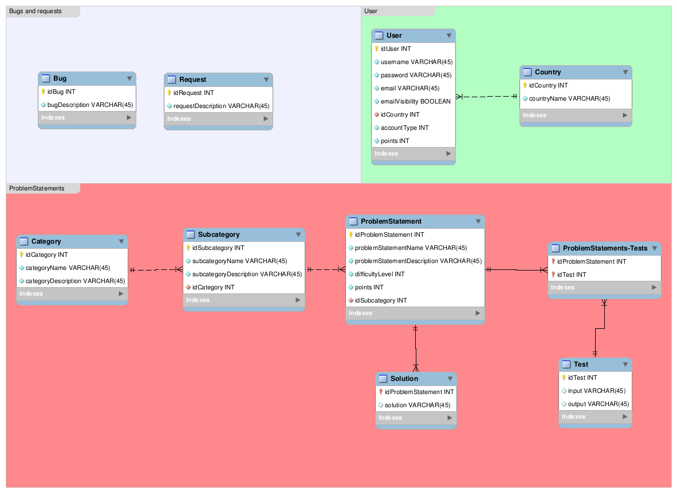

## 2.2. Schema of relational database

User(idUser, username, password, email, email visibility, idCountry, accountType, points)

Country(idCountry, countryName)

Bug(idBug, bugDescription)

Request(idRequest, requestDescription)

Category(idCategory, categoryName, categoryDescription)

Subcategory(idSubcategory, subcategoryName, subcategoryDescription, idCategory)

ProblemStatement(idProblemStatement, problemStatementName, problemStatementDescription, difficultyLevel, points, idSubcategory)

Solution(idProblemStatement, solution)

Test(idTest, input, output)

ProblemStatements-Tests(idProblemStatement, idTest)

# 3. Tables

## 3.1. User

Information about users registered on our platform is stored in User table.

|  |  |  |  |
| --- | --- | --- | --- |
| Name | Datatype | Primary Key? | Foreign key? |
| idUser | int | Yes | No |
| username | varchar | No | No |
| password | varchar | No | No |
| email | varchar | No | No |
| emailVisibility | boolean | No | No |
| accountType | int | No | No |
| idCountry | int | No | Yes |
| points | int | No | No |

## 3.2. Country

Country table keeps information about all countries that exist in the world.

|  |  |  |  |
| --- | --- | --- | --- |
| Name | Datatype | Primary Key? | Foreign key? |
| idCountry | int | Yes | No |
| countryName | varchar | No | No |

## 3.3. Bug

Users can report bugs they encounter during their time on our platform. Those reports will be stored in this table where they will be available for review by our administrators.

|  |  |  |  |
| --- | --- | --- | --- |
| Name | Datatype | Primary Key? | Foreign key? |
| idBug | int | Yes | No |
| bugDescription | varchar | No | No |

## 3.4. Request

Users can request new feature, new problem statement or new problem category. Those requests are stored in Request table where they will be available for review by our administrators.

|  |  |  |  |
| --- | --- | --- | --- |
| Name | Datatype | Primary Key? | Foreign key? |
| idRequest | int | Yes | No |
| requestDescription | varchar | No | No |

## 3.5. Category

This table stores information about all problem categories that our platform offers. Categories are Algorithms, Data Structures etc...

|  |  |  |  |
| --- | --- | --- | --- |
| Name | Datatype | Primary Key? | Foreign key? |
| idCategory | int | Yes | No |
| categoryName | varchar | No | No |
| categoryDescription | varchar | No | No |

## 3.6. Subcategory

Each category has one or more subcategories, which are stored in this table. Subcategories of Algorithms category are Searching, Sorting, Linked Lists etc...

|  |  |  |  |
| --- | --- | --- | --- |
| Name | Datatype | Primary Key? | Foreign key? |
| idSubcategory | int | Yes | No |
| subcategoryName | varchar | No | No |
| subcategoryName | varchar | No | No |
| idCategory | int | No | Yes |

## 3.7. ProblemStatement

The main functionality of our platform is solving problem statements. Therefore, this table is used for storing them.

|  |  |  |  |
| --- | --- | --- | --- |
| Name | Datatype | Primary Key? | Foreign key? |
| idProblemStatement | int | Yes | No |
| problemStatementName | varchar | No | No |
| problemStatementDescription | varchar | No | No |
| points | varchar | No | No |
| difficultyLevel | boolean | No | No |
| idSubcategory | int | No | Yes |

## 3.8. Solution

Solution table is used for storing solutions to existing problem statements.

|  |  |  |  |
| --- | --- | --- | --- |
| Name | Datatype | Primary Key? | Foreign key? |
| idProblemStatement | int | Yes | Yes |
| solution | varchar | No | No |

## 3.9. Test

Each problem statement has multiple tests, which are used for validating user’s solution. These tests are stored in Test table.

|  |  |  |  |
| --- | --- | --- | --- |
| Name | Datatype | Primary Key? | Foreign key? |
| idTest | int | Yes | No |
| input | varchar | No | No |
| output | varchar | No | No |

## 3.10. ProblemStatements-Test

This table connects all of the problem statements to corresponding test cases.

|  |  |  |  |
| --- | --- | --- | --- |
| Name | Datatype | Primary Key? | Foreign key? |
| idProblemStatement | int | Yes | Yes |
| idTest | int | Yes | Yes |